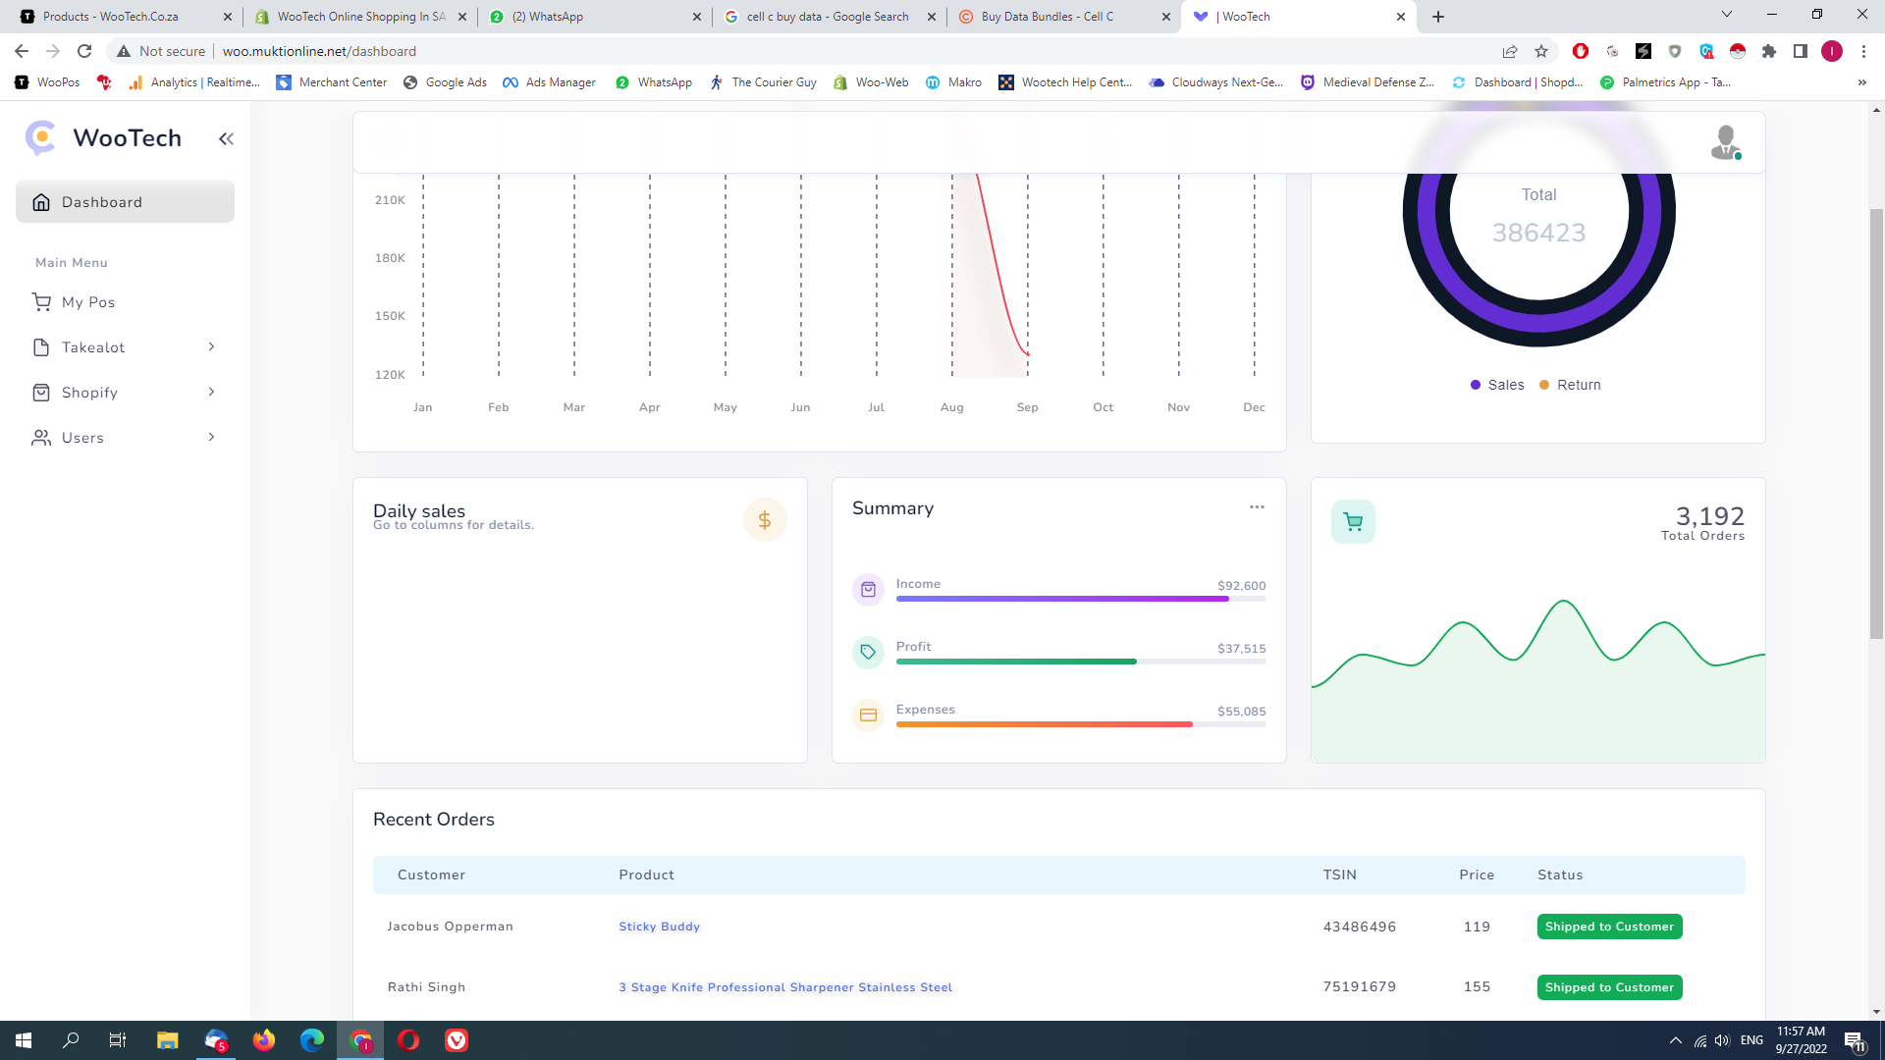

1 – daily Sales – please Add last 7 days Sales Amount Chart

2- Total orders – please add last 7 days order Charger

3 – remove Summary

4 – please Also Fix 1St chart – must be bar chart With Amount

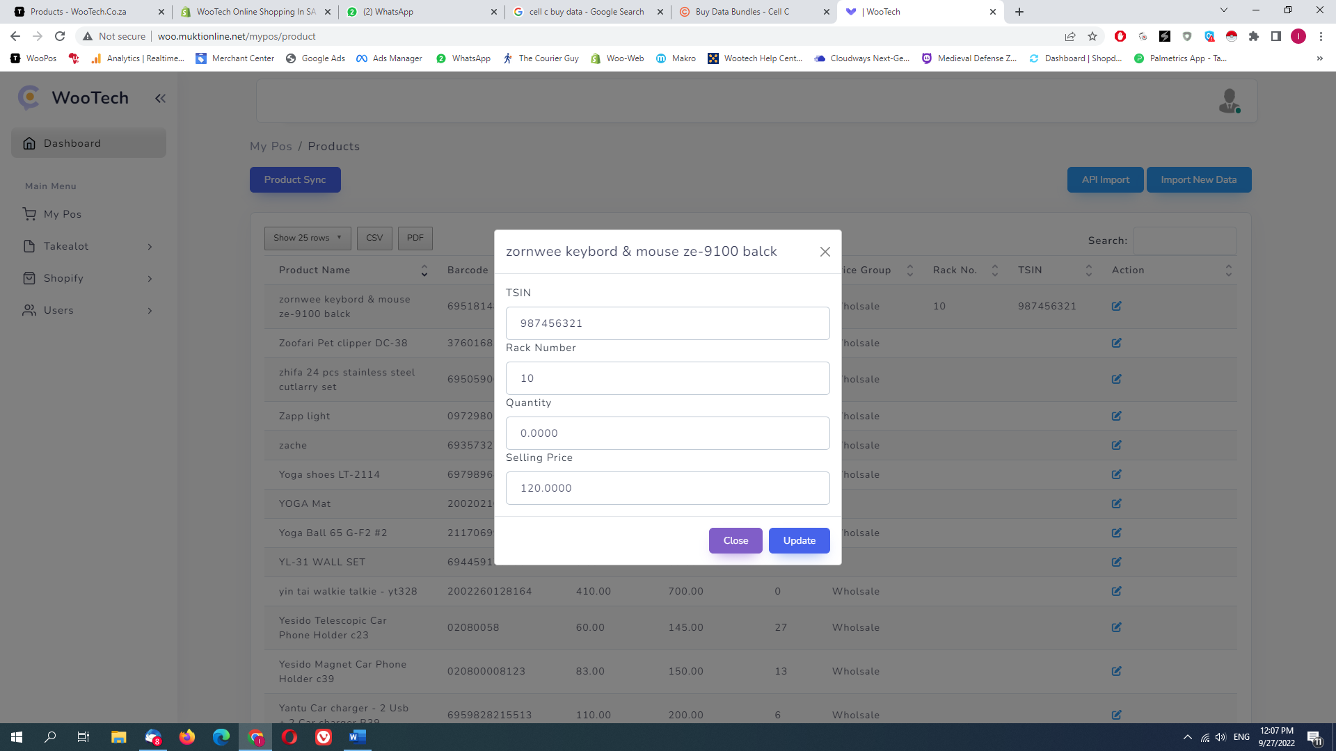



1. – WE needs to Add Multiple Tsin in 1 product – like 987456321 , 987456300 , 123456789 , 567893345
2. Quantity on my pos – Disable For update from here – And Qty remove last 4 Zero Qty must be like – 1 or 10 or 5 - no zero at end
3. Selling Price must Have 2 Zero at last - 120.00
4. Add barcode Edit option Here

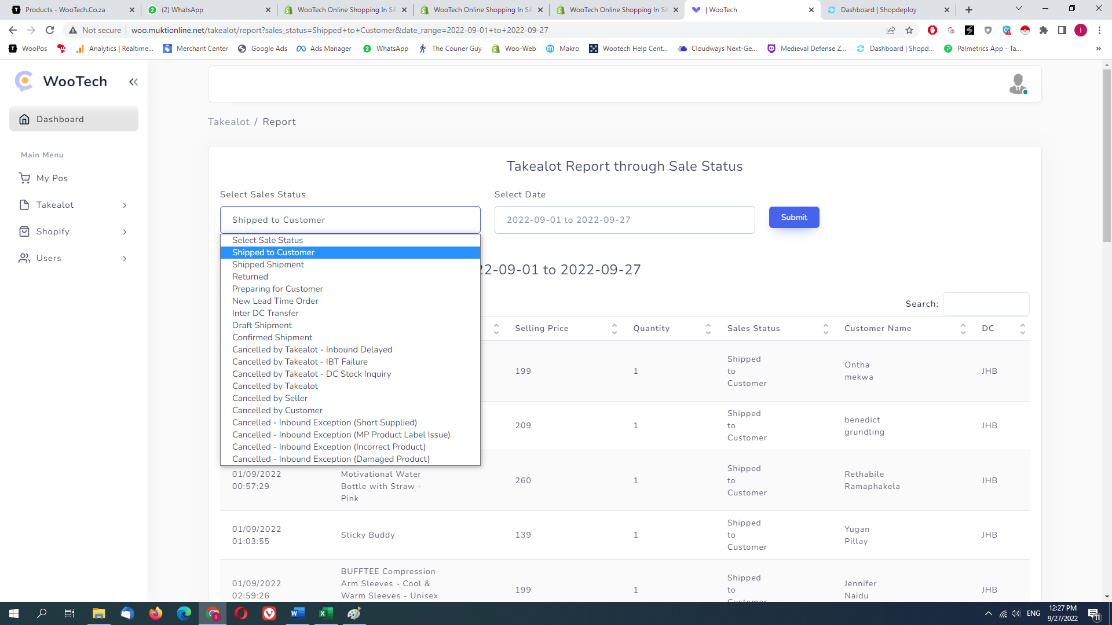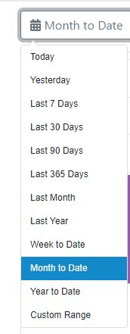



1. Sales Status – please Add – Top Selling Product / Top return product /
2. Please use This Type Of date Selector provided next To Image - by Default last 30 Days
3. At yellow Space Please Put Amount – like Last 30 days Shipped To customer Total Amount

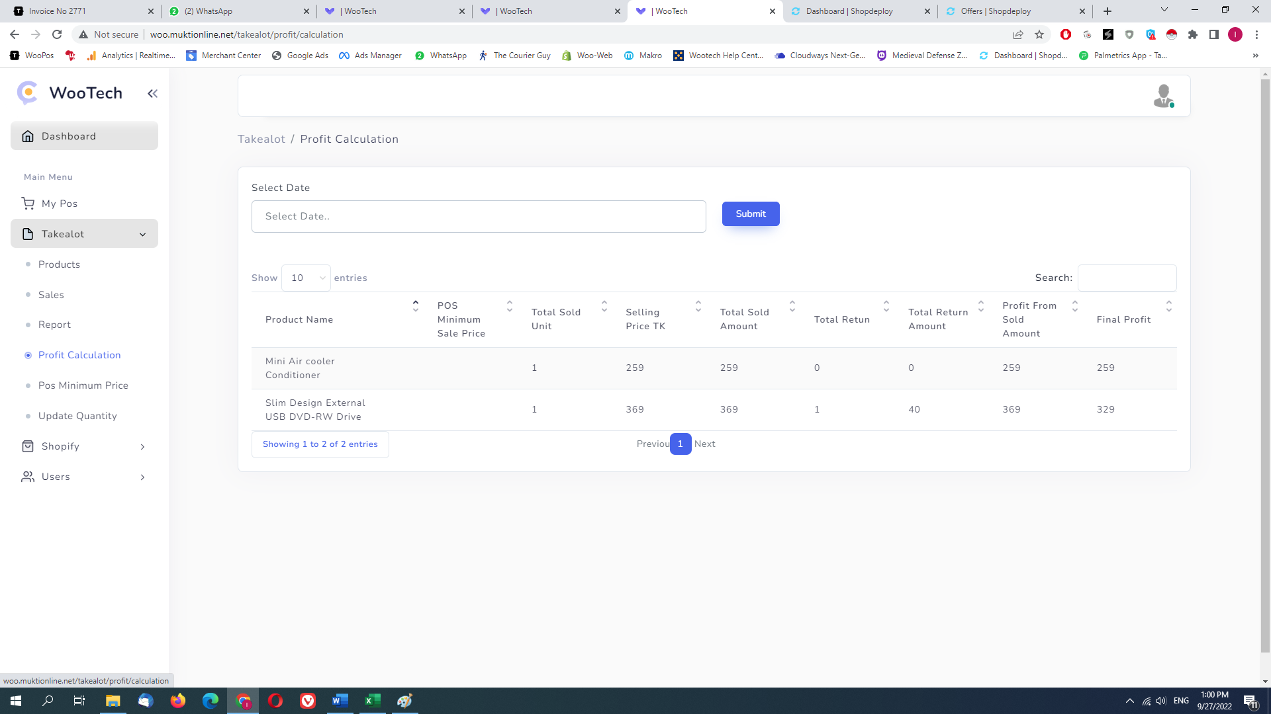

1. Profit Calculator use Same Date Selector And show default 30 Days data
2. Please double Check profit calculator Page is not Working Properly

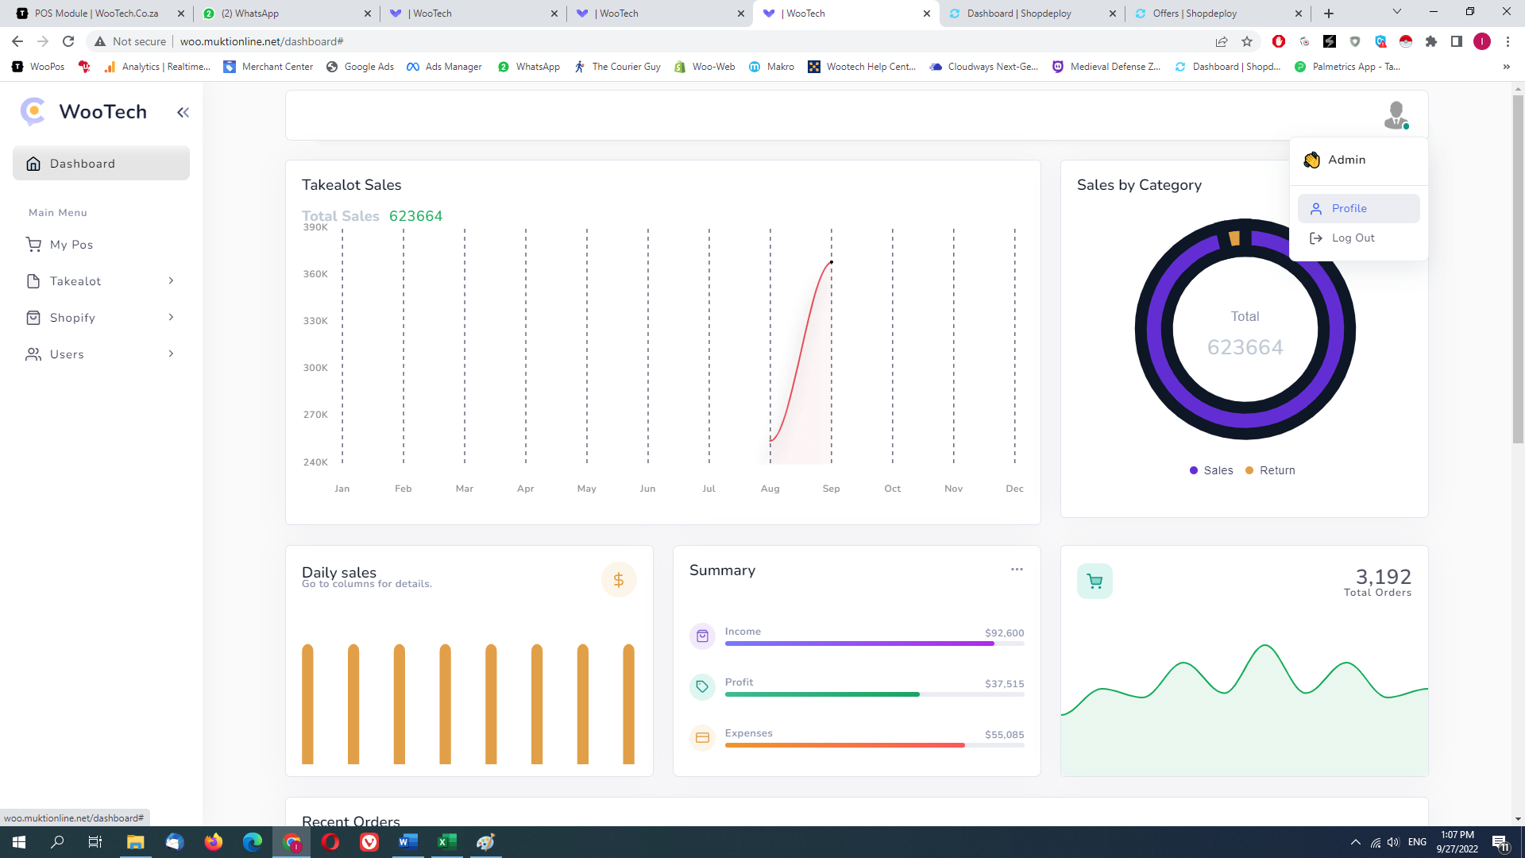



Please check Profile is not Working

Change Application name FromWootech to Sync